Tools for Alloy Design: The C-window in Hardmetals by a Simplified Tool
Hardmetals, also called cemented carbides, are composite materials made of refractory metal carbides (such as tungsten carbide WC, titanium carbide TiC, etc.) and bonding metals (such as cobalt Co, nickel Ni, etc.). They are produced through powder metallurgy.
The application of computational thermodynamics to predict and adjust microstructures in hardmetals is widespread. Hardmetals have a complex microstructure and the type, fraction and composition of the hard phases, and the composition of the binder phase can be calculated.
Hardmetals are produced by sintering at high temperatures in a region where the binder phase is liquid. Sintering is thus mostly governed by diffusion in the liquid, which is rapid. Therefore, equilibrium calculations can give reasonable predictions of the phase compositions after sintering. The types of information that can be obtained from calculations are melting and solidification temperatures, composition of the binder, the types and compositions of carbides/nitrides.
Another type of important information is the composition and temperature constraints that need to be applied to avoid detrimental phases in the hardmetal (eta-phase (M6C) or graphite), often referred to as the carbon window. The figures below show how to obtain the C-window in the Co-W-C system. The tool is available online after registration.

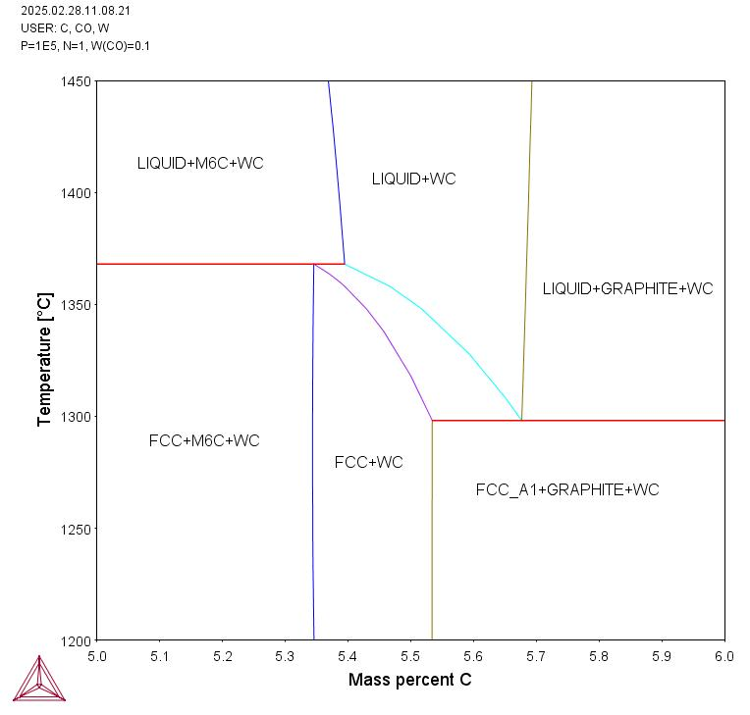 | 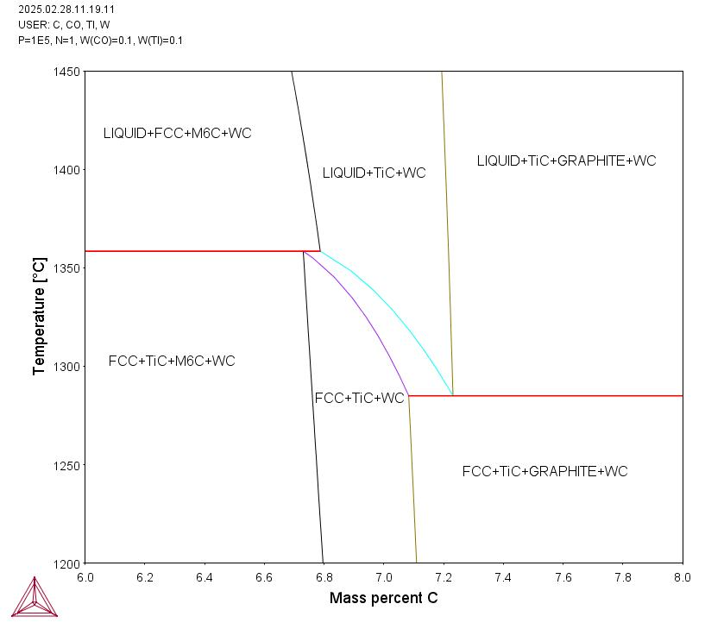
Fig. 1: The calculated C-Co-W phase diagram at 10wt%Co (15.5at%Co), showing the limiting C contents to avoid graphite (gra) or M6C/eta-phase (the C-window). | Fig. 2: The calculated C-Co-W-Ti phase diagram at 10wt%Co and 10wt%Ti. The melting temperatures and C window are changed compared to Fig.1.

To calculate these diagrams you need to use a software for thermodynamic calculations and have access to a database for hardmetals. To simplify the access to information on melting temperatures and phase stabilities a tool has been developed. The tool is based on data analysis and gives rapid and easy access to melting temperatures and C balance for alloys with varying compositions. No additional software or database is needed. In addition, the fractions of each phase are visualized. This can be important when assessing the C-window since very small fractions of eta-phase or graphite may lie within the limits of uncertainty of the calculations. The figures below show how to use the tool.
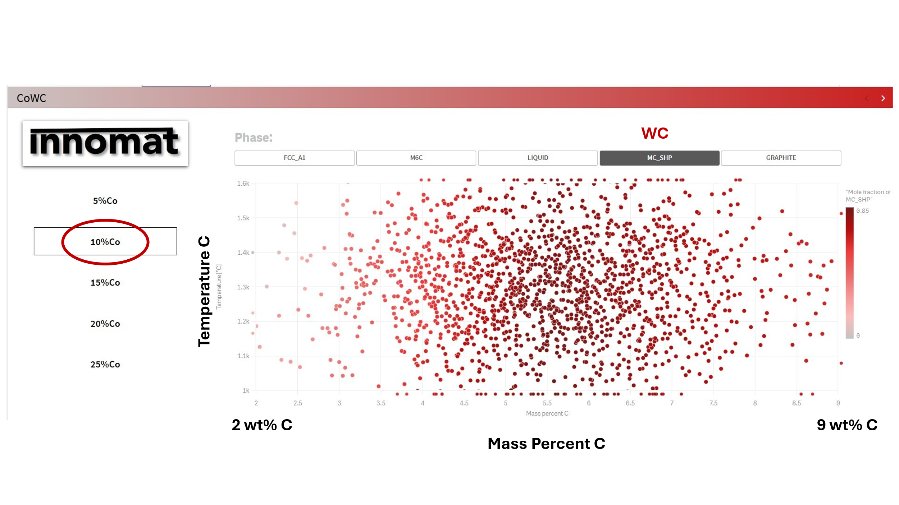
Figure 1 Select the composition (10%Co in this example) and select the phase you want to study. Each datapoint represents a composition. In this figure you can see that all points contain WC (WC containing compositions are marked in red).
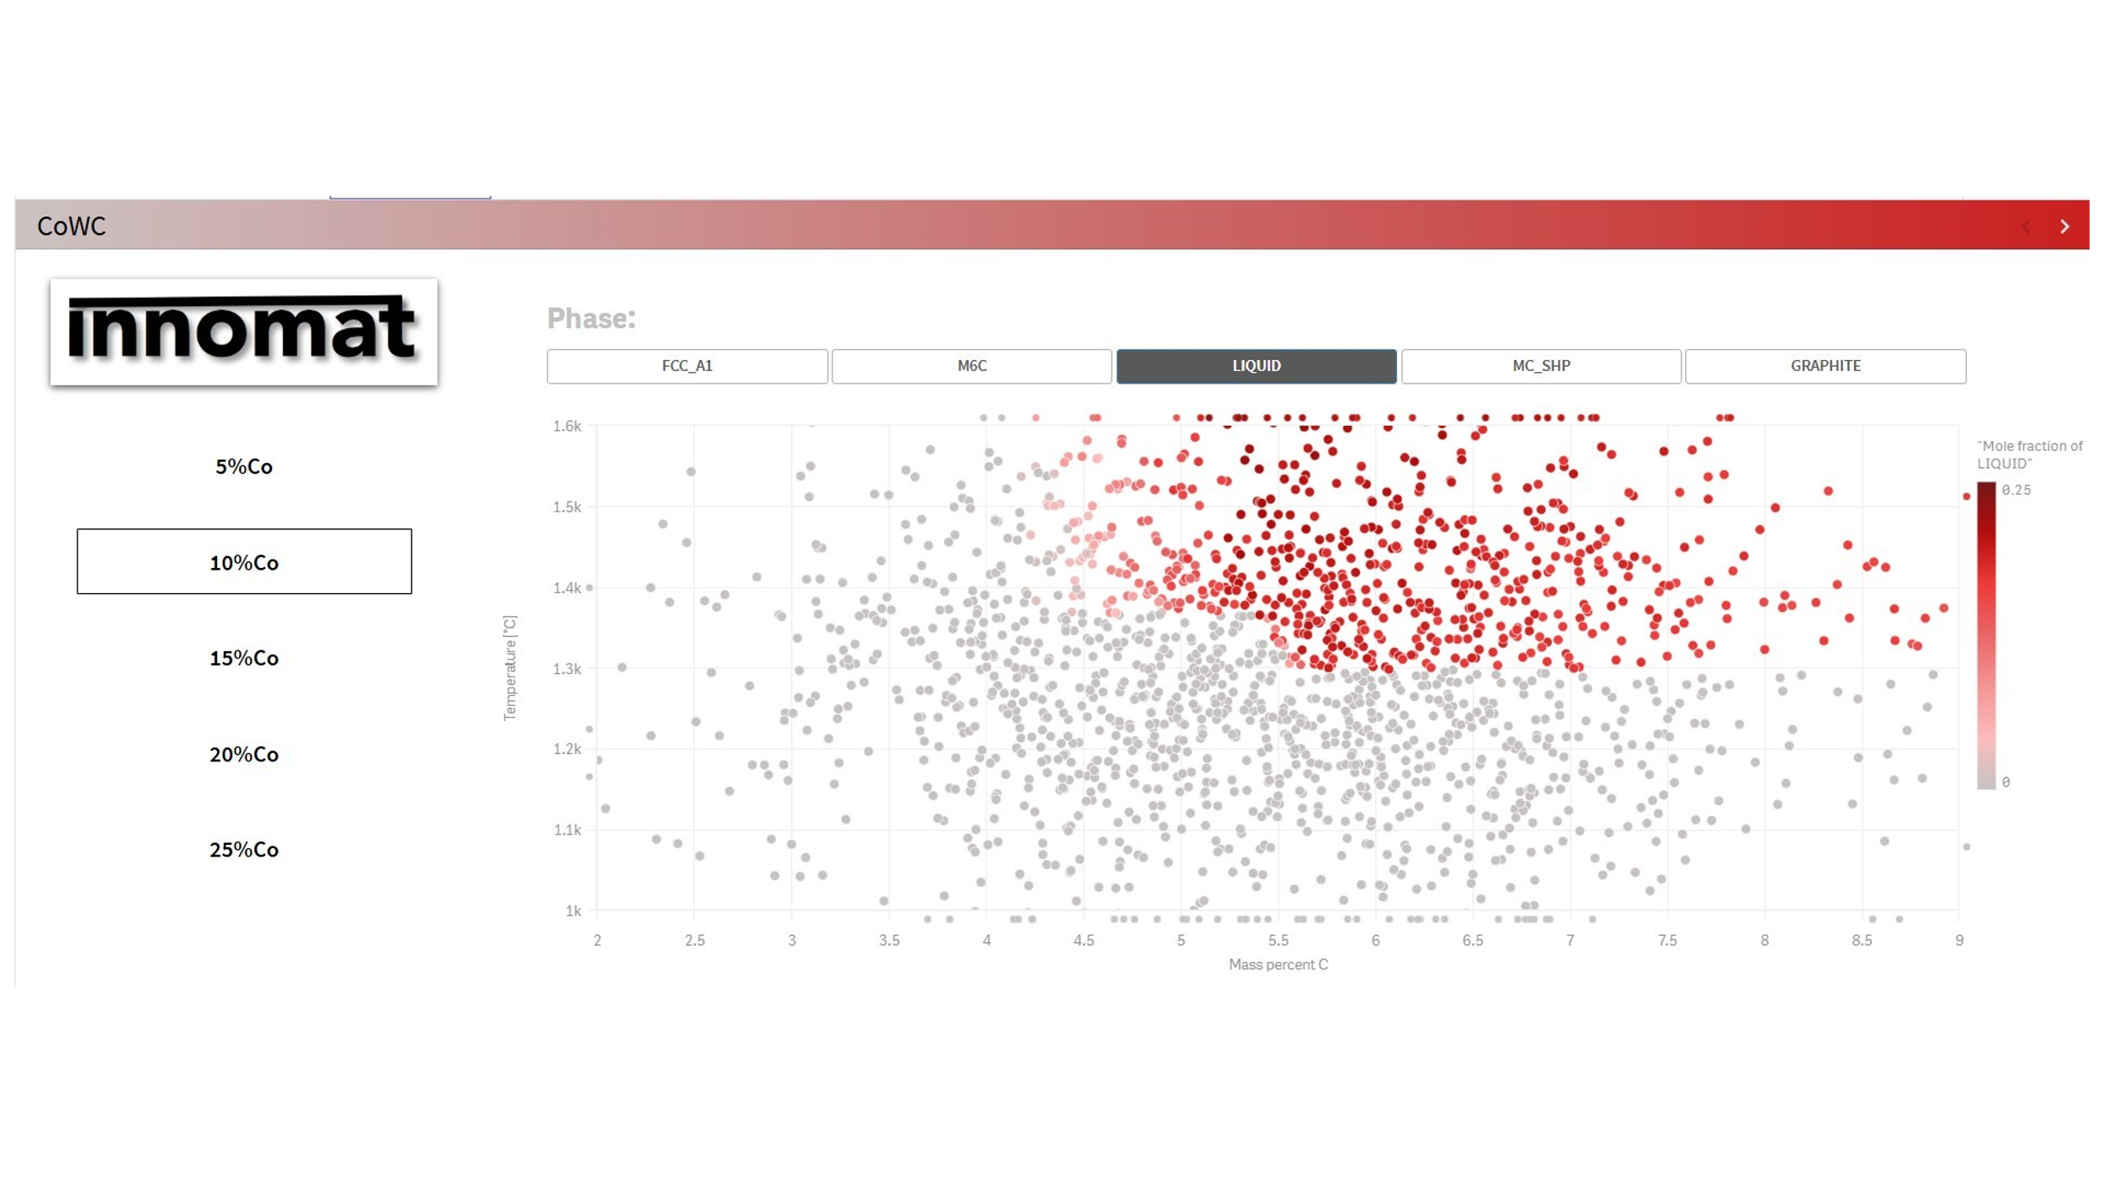
Figure 2 In this figure the points containing liquid phase are marked in red, and this diagram shows the melting temperature at varying C-contents.
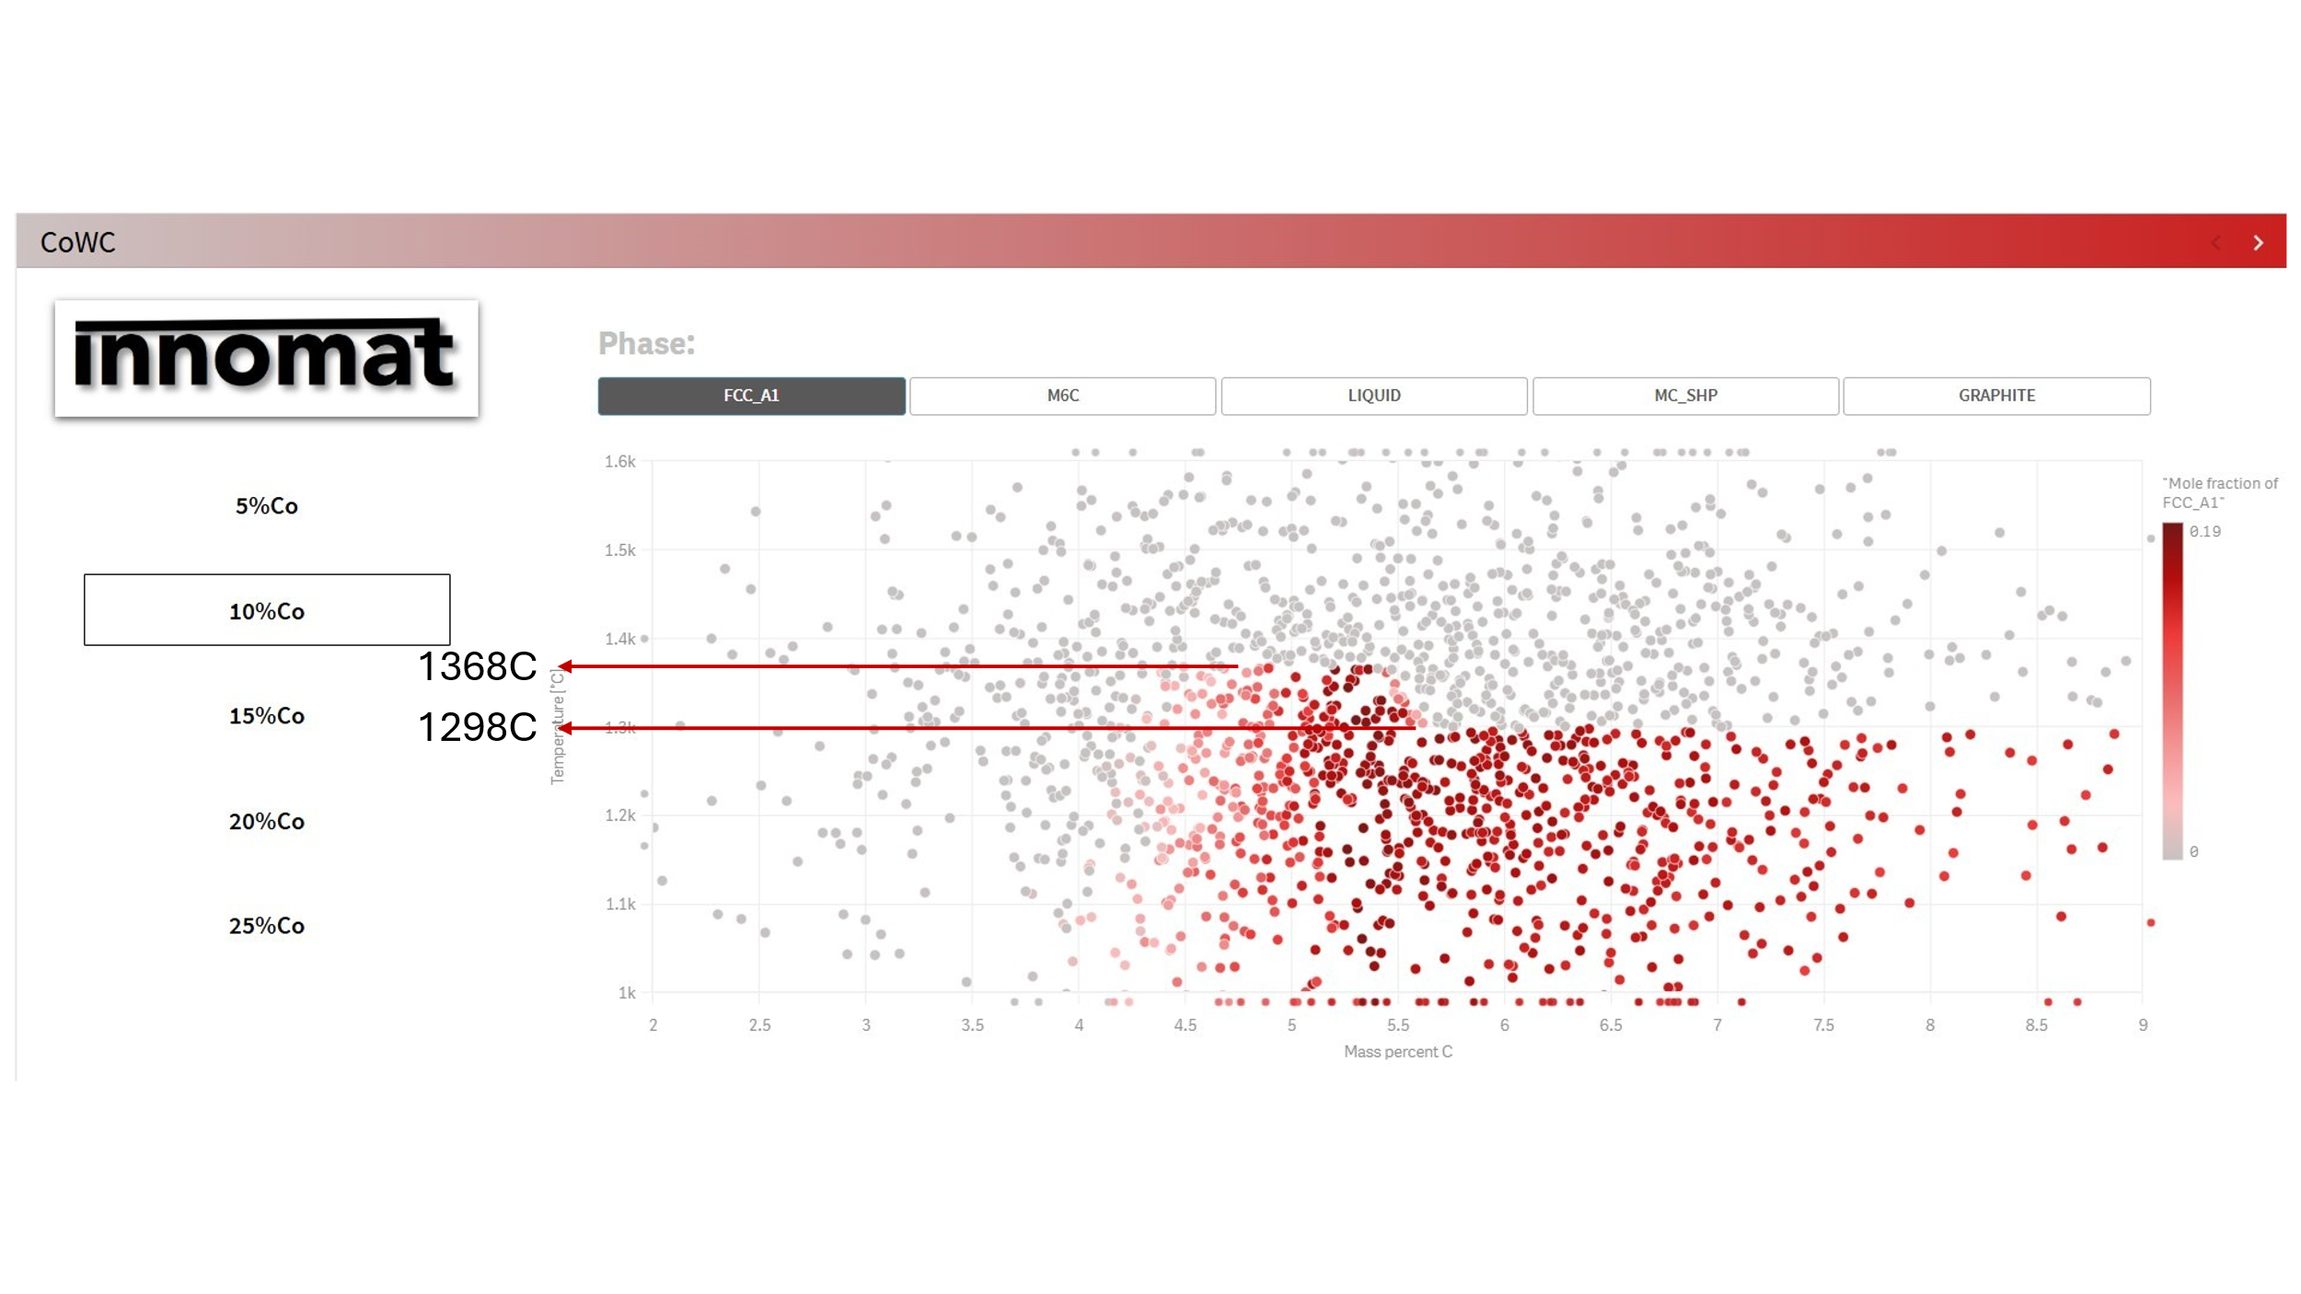
Figure 3. In this figure the points containing Co binder (fcc) are marked in red. Here the melting points are marked with lines .
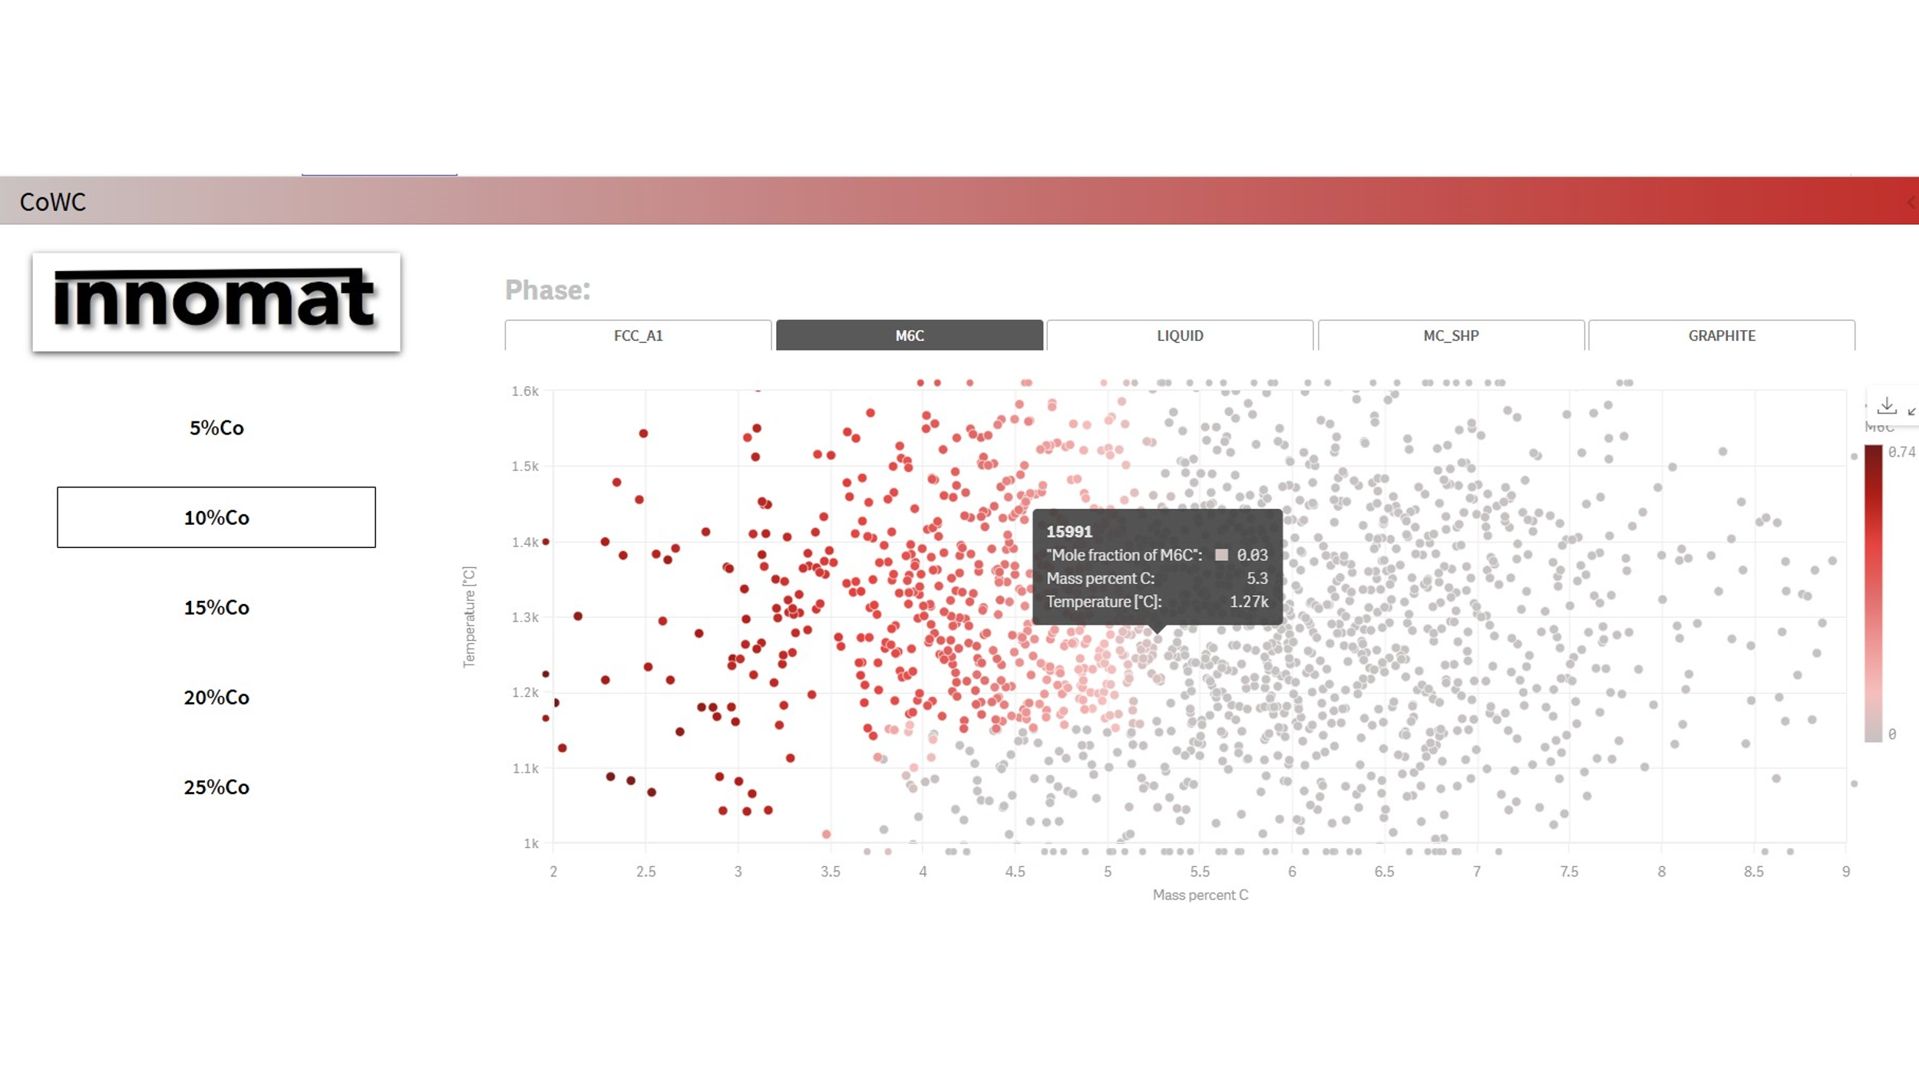
Figure 4. In this figure the compositions containing the M6C carbide are marked in red. Moving the pointer over the diagram will give you the exact amount of the carbide (shown in the black box).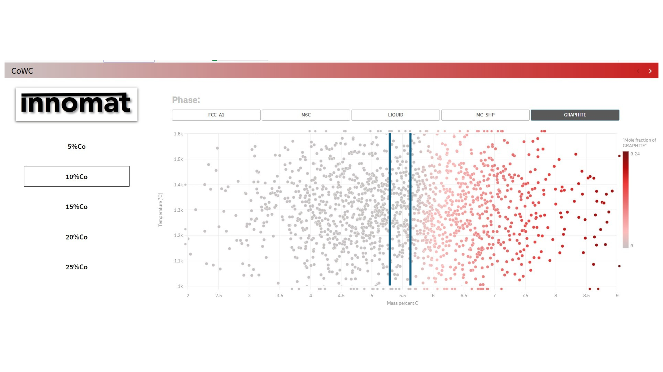
Figure 5. The C-window is shown in this figure. The red points to the right show the datapoints where graphite is present.

